Real-Time Communication System Powered by AI for Specially Abled

**Submitted By**

# TEAM LEAD : Ravikumar

**TEAM MEMBERS : Dhanush**

# Praveen Kumar

# Indhuja

# Dhasarathi

1. **INTRODUCTION**

# Overview

People get to know one another by sharing their ideas, thoughts, and experiences with those around them. There are numerous ways to accomplish this, the best of which is the gift of "Speech." Everyone can very convincingly transfer their thoughts and understand each other through speech. It will be unjust if we overlook those who are denied this priceless gift: the deaf and dumb. In such cases, the human hand has

remained the preferred method of communication.

# Purpose

The project's purpose is to create a system that translates sign language into a human understandable language so that ordinary people may understand it.

# LITERATURE SURVEY

A literature review is **a comprehensive summary of previous research on a topic**. The literature review surveys scholarly articles, books, and other sources relevant to a

particular area of research. The review should enumerate, describe, summarize, objectively evaluate and clarify this previous research.

In our project,We have taken the literature survey on IEEE papers.An intelligent communication device is developed to assist nonverbal, motor-disabled persons in the generation of written and spoken messages. The device is centered on a knowledge

base of the grammatical rules and message elements. A belief reasoning scheme

based on both the information from external sources and the embedded knowledge is used to optimize the process of message search

# Existing problem

Some of the existing solutions for solving this problem are:

# Technology

One of the easiest ways to communicate is through technology such as a smart phone or laptop. A deaf person can type out what they want to say and a person who is blind or has low vision can use a screen reader to read the text out loud. A blind person can also use voice recognition software to convert what they are saying in to text so that a

person who is Deaf can then read it.

# Interpreter

If a sign language interpreter is available, this facilitates easy communication if the

person who is deaf is ﬂuent in sign language. The deaf person and person who is blind can communicate with each other via the interpreter. The deaf person can use sign language and the interpreter can speak what has been said to the person who is blind and then translate anything spoken by the blind person into sign language for the deaf person.

# Just Speaking

Depending on the deaf person's level of hearing loss, they may be able to communicate with a blind person who is using speech. For example, a deaf person may have suﬃcient residual hearing (with or without the use of an assistive hearing device such as a hearing aid) to be able to decipher the speech of the person who is blind or has low vision. However, this is often not the most effective form of communication, as it is very dependent on the individual circumstances of both people and their environment (for

example, some places may have too much background noise).

# Problem statement deﬁnition

Deaf and dumb person is not able to interact with normal person and the normal person is not able understand their way of speaking . In order to communicate with specially abled person ,the normal people needs to understand sign language.In this project we have designed and developed a system which lowers the communication gap between speech hearing impaired people and normal people that is we have built a system that enables communications between deaf-dumb person and a normal person. A convolution neural network is being used to develop a model that is trained on various hand movements. This model is used to create an app. This programme allows deaf and hard of hearing persons to communicate using signs that are then translated into human readable text.

# IDEATION AND PROPOSED SOLUTION

The ultimate aim of this is to generate a large quantity of ideas that the team can then ﬁlter and cut down into the best, most practical or most innovative ones in order to inspire new and better design solutions and products.Ideation is the process where you generate ideas and solutions through techniques such as Empathy Map Canvas,

Brainstorming,etc. Ideation is also the third stage in the Design Thinking

process.Proposed solution is the one in which we are making use of a convolution neural network to create a model that is trained on different hand gestures. A website is built which uses this model. This website enables deaf and dumb people to convey their information using signs which get converted into human-understandable English alphabets and is given as output.

# Empathy map canvas

An empathy map is a collaborative visualization used to articulate what we know about a particular type of user. It externalizes knowledge about users in order to create a shared understanding of user needs and aid in decision making.Traditional empathy maps are split into four quadrants(Says, Thinks, Hear and Sees) with the user or

persona in the middle. Empathy maps provide a glance into who a user is as a whole and are not chronological or sequential.The Says quadrant contains what the user says out loud in an interview or some other usability study. Ideally, it contains verbatim and

direct quotes from research.The Thinks quadrant captures what the user is thinking throughout the experience.The Hear quadrant is the user’s emotional state, often

represented as an adjective plus a short sentence for context.The See quadrant

encloses the actions the user takes.Empathy maps should be used throughout project to establish common ground among team members and to understand and prioritize user needs. Empathy mapping can be driven by any method of qualitative research.They can help team members to understand what aspects of their user they know and where they would need to gather more user data.Empathy maps are best used from the very

beginning of the design process.Both the process of making an empathy map and the ﬁnished artifact have important beneﬁts for the project.

# Ideation & Brainstorming

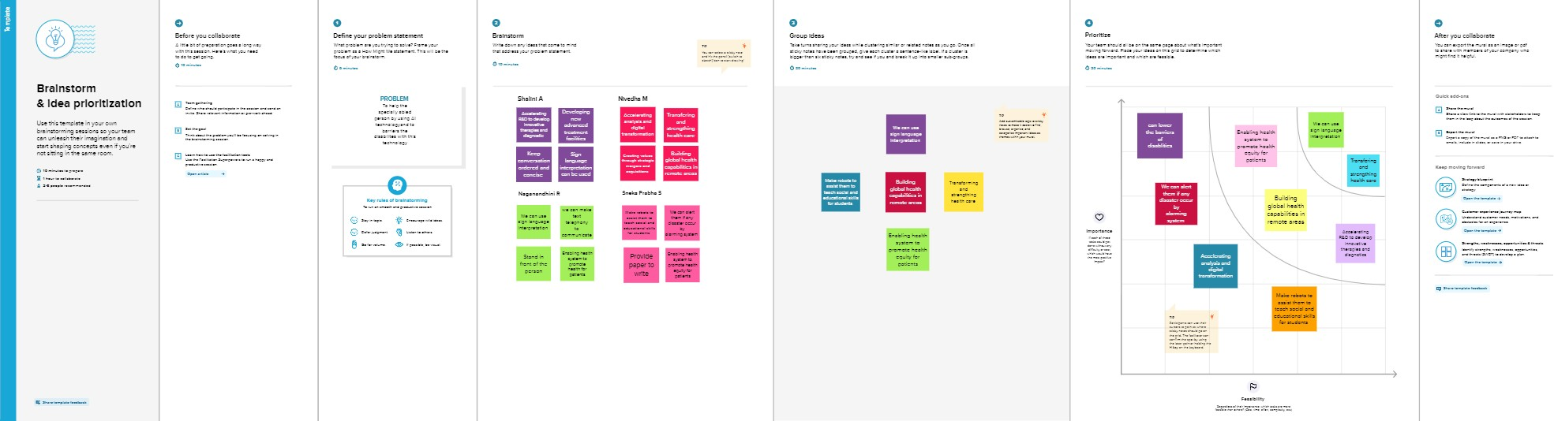

Ideation is the process where you generate ideas and solutions through techniques such as Empathy Map Canvas, Brainstorming,etc. Ideation is also the third stage in the Design Thinking process.Brainstorming can be used to generate possible solutions for simple problems, but it is unrealistic to expect it to accomplish most problem-solving or planning tasks.First, the top priority of brainstorming is quantity over

[quality](https://www.wrike.com/project-management-guide/faq/what-is-quality-in-project-management/).Brainstorming is the ﬁrst step in the exploration phase of a new [project](https://www.wrike.com/project-management-guide/faq/what-is-a-project-in-project-management/), so it's important to be open to all ideas and possibilities. Problems arise when team members ﬁlter out the good ideas from the not-so-good ones out of a fear of rejection or

judgment. The technique is of value as part of a larger effort that includes individual generation of information and ideas and subsequent compilation, evaluation, and selection. Brainstorming can be used to generate components of a plan, process, solution, or approach and to produce checklists.The value of the process is that more good ideas are produced in less time than would be produced in a typical meeting or conference.

# Proposed Solution

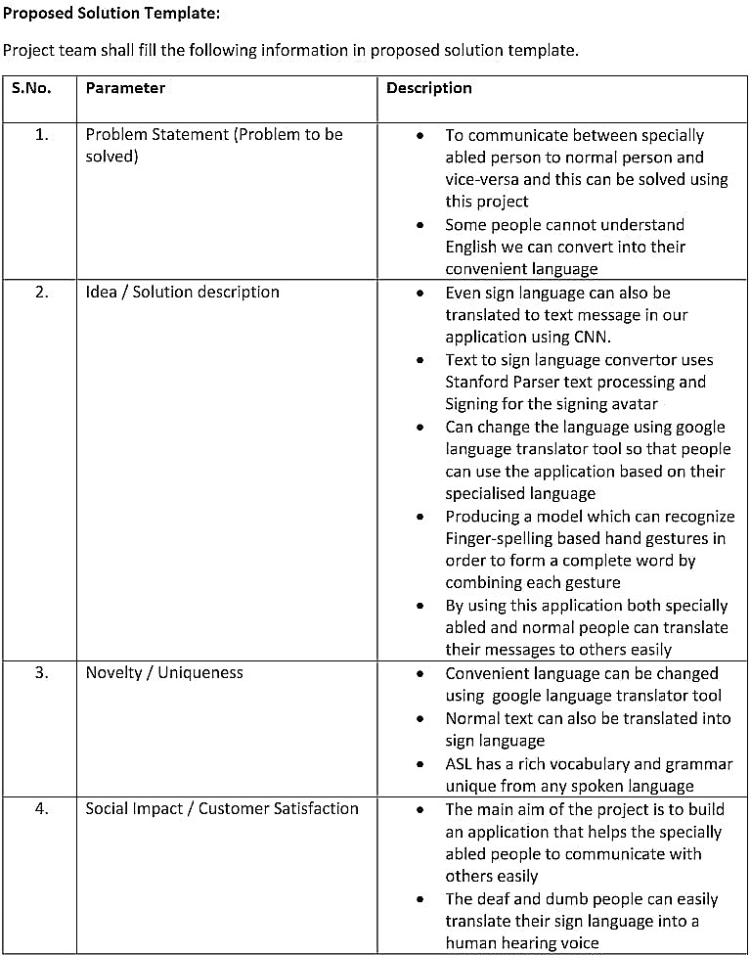

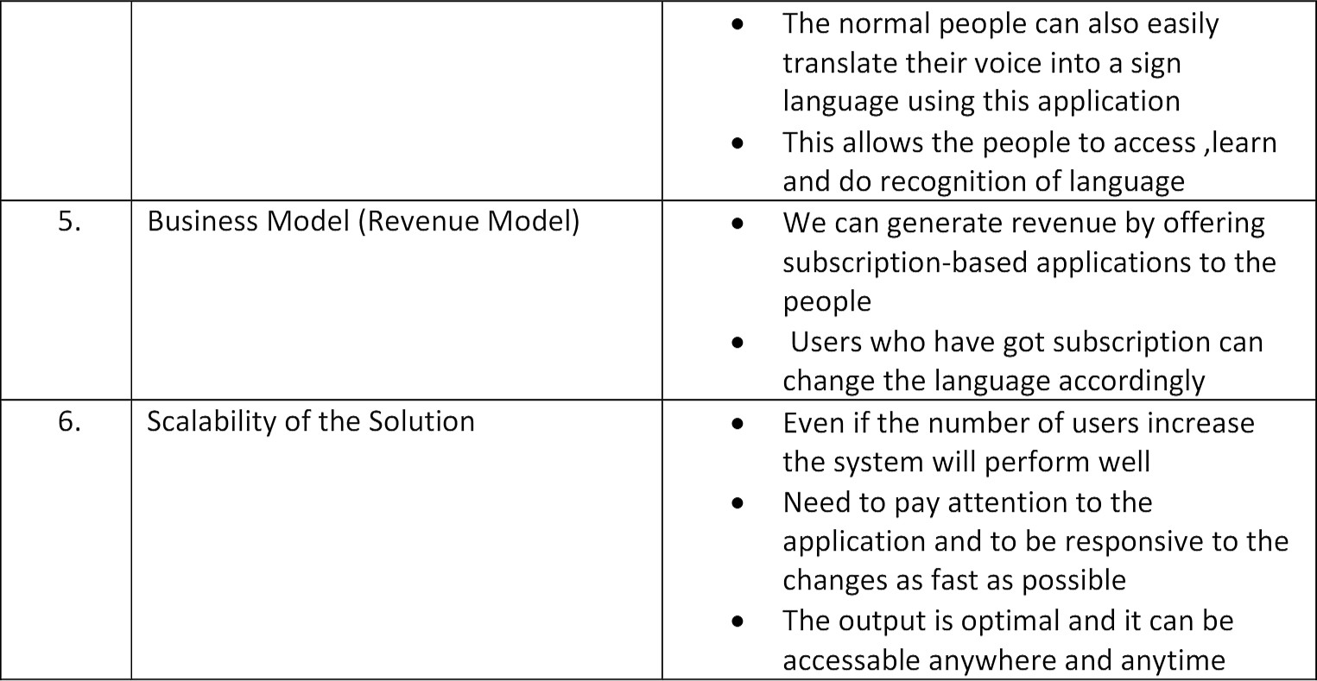

Proposed solution is the one in which we are making use of a convolution neural network to create a model that is trained on different hand gestures. A website is built which uses this model. This website enables deaf and dumb people to convey their information using signs which get converted into human-understandable English alphabets and is given as output.The proposed solution should relate the current

problem to a desired result for the problem occuring the design and describe the

beneﬁts that will accrue when the desired result is achieved.The proposed solution section should offer the solution speciﬁcally, with enough detail so that the reader understands exactly what we're proposing. Indicating how the proposed solution will solve the problem and that will provide tangible beneﬁts. Speciﬁcally, explaining how it will meet the objectives and abide by the constrains outlined in the problem deﬁnition. A proposed solution composed of a list of activities or tasks that will be associated with

the project, but it doesn't go into the same level of detail as a [project plan](https://www.nuclino.com/articles/project-plan-template-examples).It creates clarity about the goals, priorities, and requirements of the project.Proposed solution helps a team to write down the possible solutions to a clearly outlined problem.

# Problem solution ﬁt

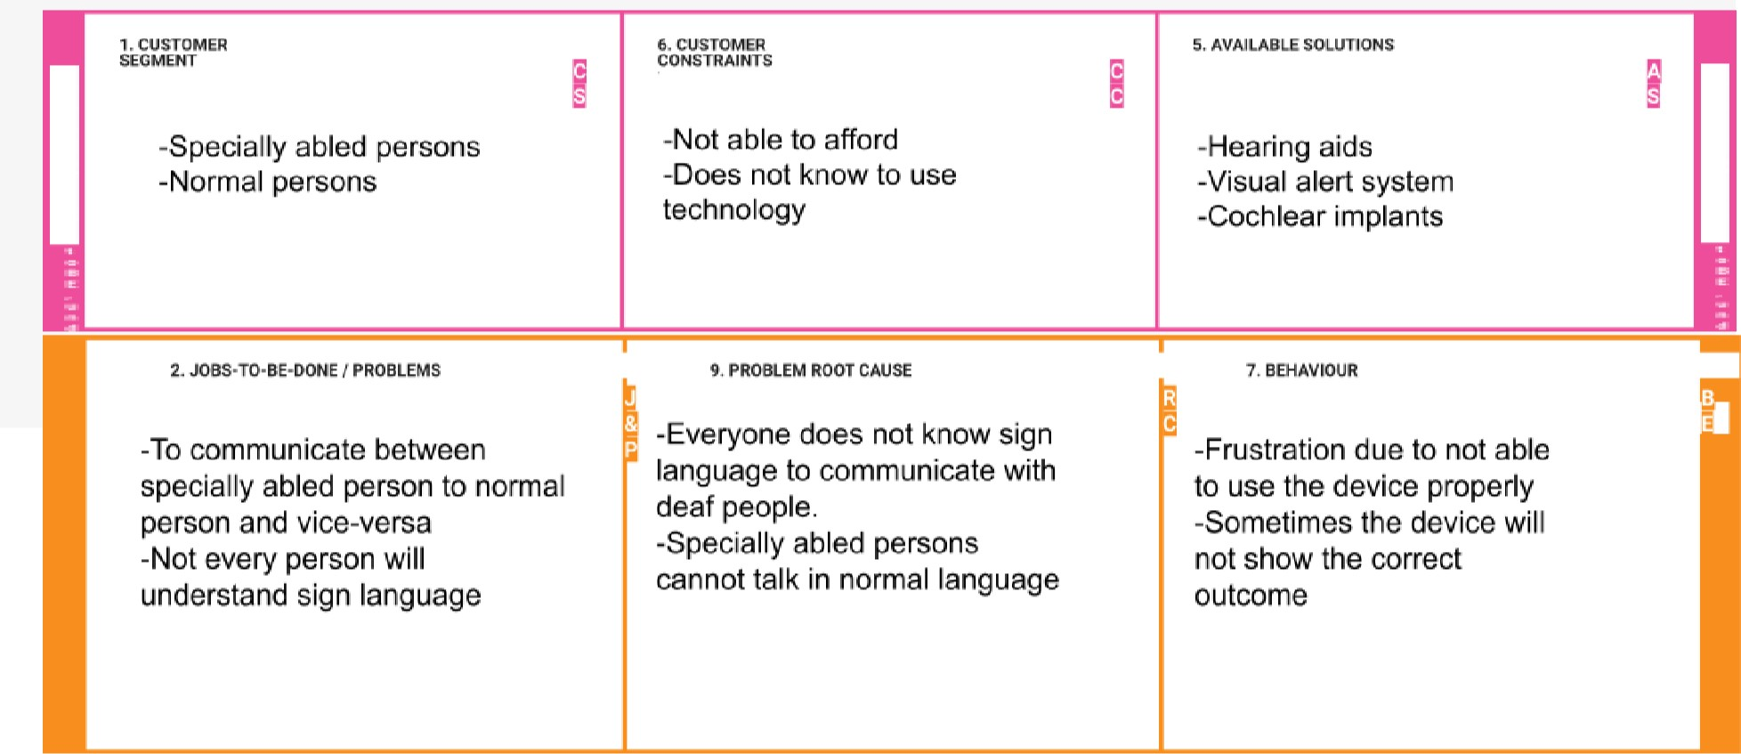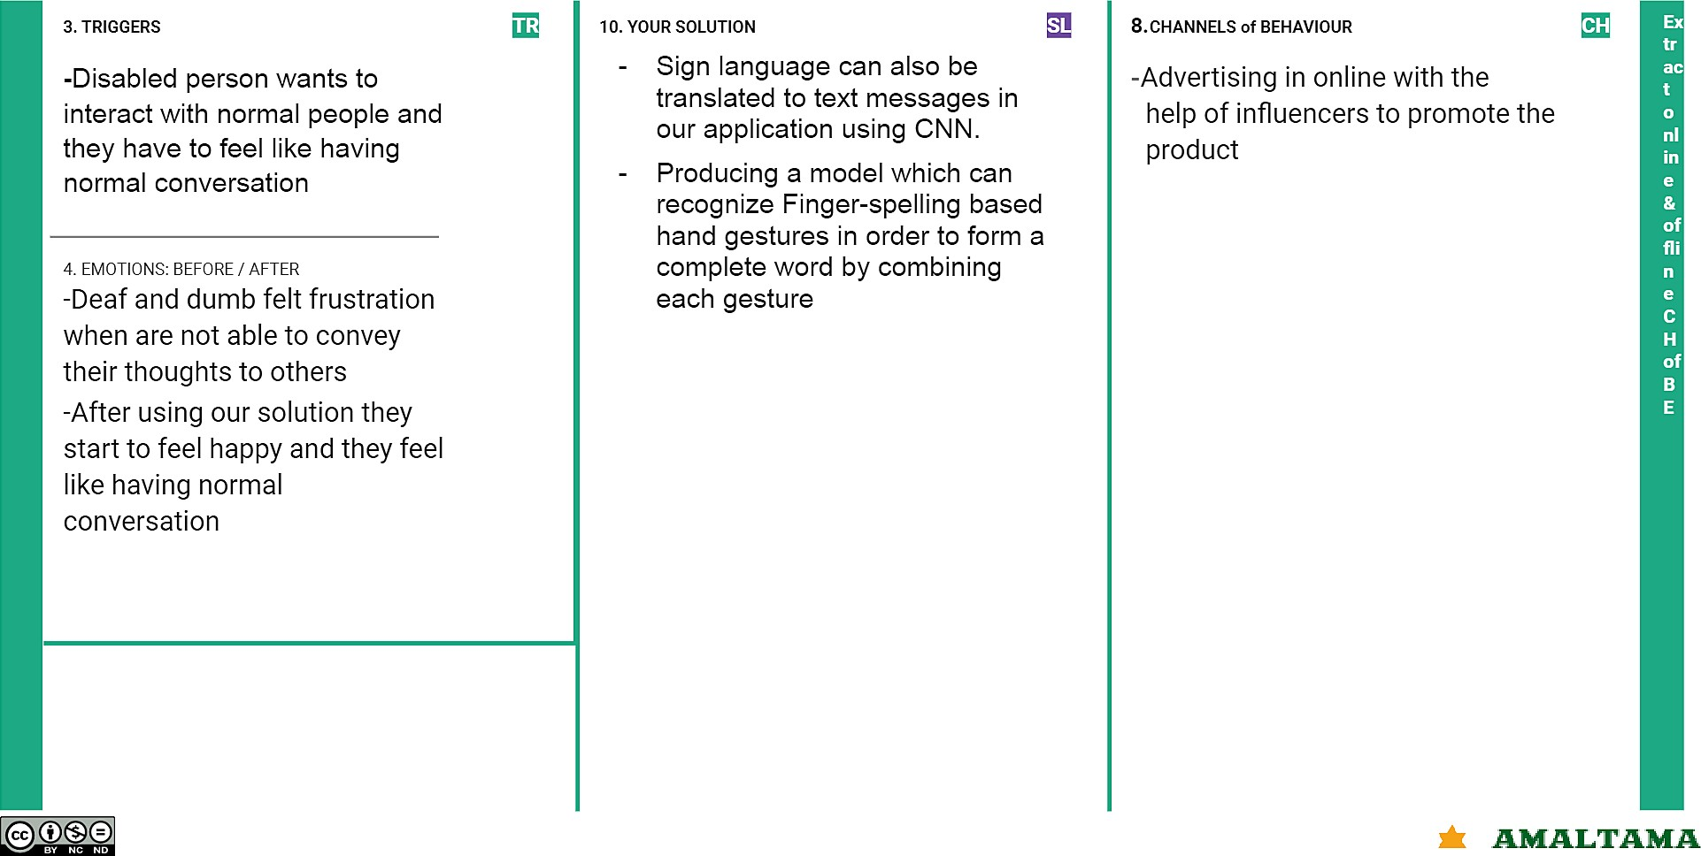

The Problem-Solution Fit simply means ﬁniding the problem in the existing design and tries to give the solution for it.The Problem-Solution Fit is based on the principles of

Lean Startup, LUM (Lazy User Model) and User Experience design. It helps us to identify behavioral patterns and recognize what would work and why. It is used to identify solutions with higher chances of solution adoption, reduce time spent on testing and

get a better overview of the current situation.It helps us to solve complex problem and also helps to ﬁnd the existing problem in the design and gives the clear cut idea in order to overcome the problem that is been occuring in the design.

# REQUIREMENT ANALYSIS

* 1. **Functional requirement**

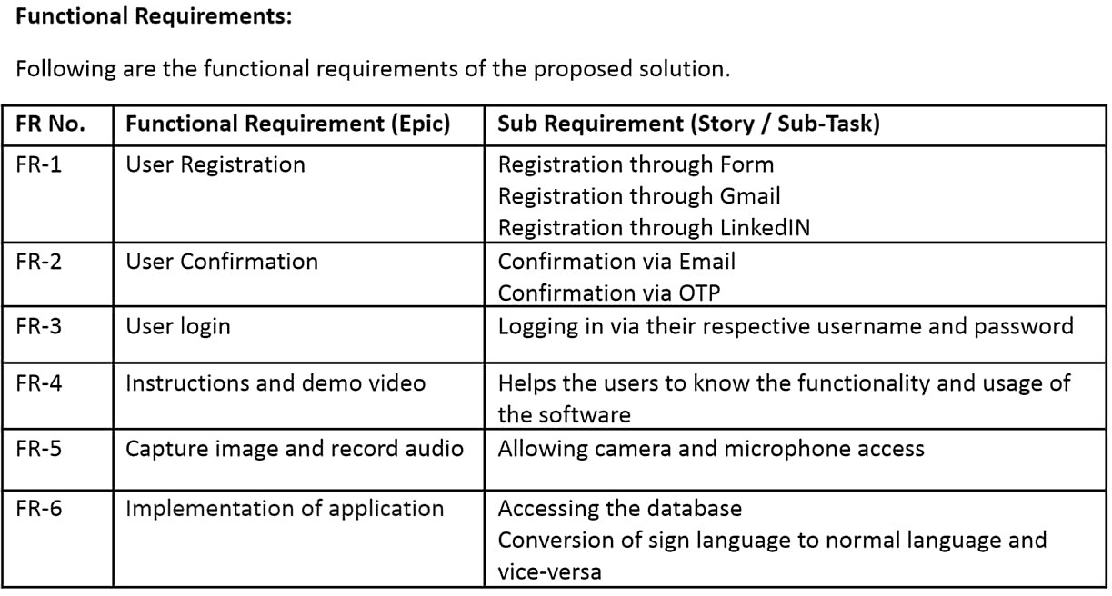

Functional Requirements are the requirements that the end user speciﬁcally demands as basic facilities that the system should offer. All these functionalities need to be necessarily incorporated into the system as a part of the design.These are represented or stated in the form of input to be given to the system, the operation performed and the output expected. They are basically the requirements stated by the user which one can see directly in the ﬁnal design, unlike the non-functional requirements.

# Non- Functional requirement

Non-functional requirements are basically the quality constraints that the system must satisfy according to the plan that is been made in the design. The priority or extent to which these factors are implemented varies from one project to other. They are also called non-behavioral requirements.They basically deals with,

* + - Usability
    - Security
    - Reliability
    - Performance
    - Availability
    - Scalability

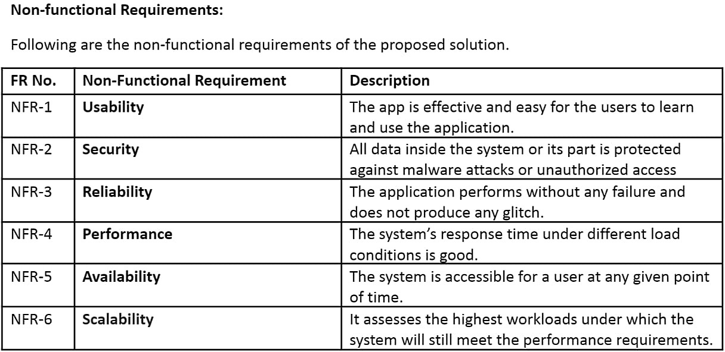

# PROJECT DESIGN

Project design is an early phase of the project lifecycle where ideas, processes,

resources, and deliverables are planned out. A project design comes before a project plan as it's a broad overview whereas a project plan includes more detailed information.The ultimate aim of our project is to covert sign language into human understandable English alphabets.In order to achieve this we should design website

which gives the facility to covert the sign langauage into English alphabets.It composed of data ﬂow diagram,solution architecture and technology architecture.Let us detailly see about in the following.

# Data Flow Diagrams

A data ﬂow diagram is a traditional visual representation of the information ﬂow within a system.A neat and clear data ﬂow diagram can depict the right amount of the system requirement graphically.It shows how data enters and leaves the system.And it shows what are things that is been used for the design.It makes a way easier in order to understand the ﬂow of the design that is to be developed. It uses deﬁned symbols like rectangles, circles and arrows, plus short text labels, to show data inputs, outputs, storage points and the routes between each destination.Those symbols helps the design team to understand the ﬂow easily.As per the requirement we design this data ﬂow desigrams.

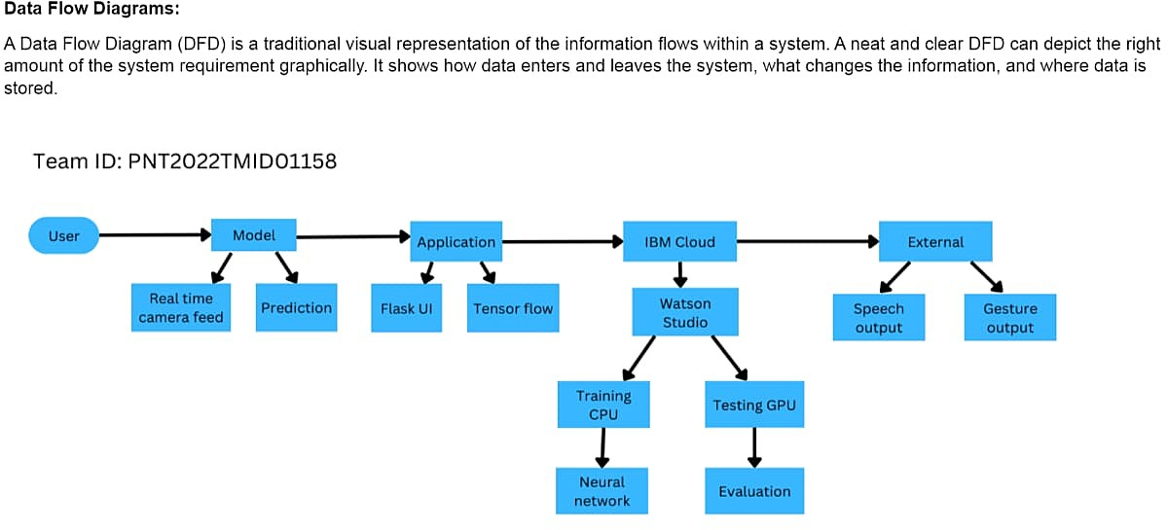

# Solution Architecture

Solution architecture is the process of developing solutions based on predeﬁned

processes, guidelines and best practices with the objective that the developed solution ﬁts within the enterprise architecture in terms of information architecture, system

portfolios, integration requirements and many more.

It can then be viewed as a combination of roles, processes and documentation that are intended to address speciﬁc business needs, requirements or problems through the

design and development of applications and information systems.

# Technical Architecture

Technical Architecture is a form of Information Technology(IT) architecture that is used to design a system. It involves the development of a technical blueprint with regard to the arrangement, interaction, and interdependence of all elements so that system- relevant requirements are met.The use of a technology architecture diagram is common practice as it provides a clear cut knowledge about the design of the system and the components that is been used in the design.

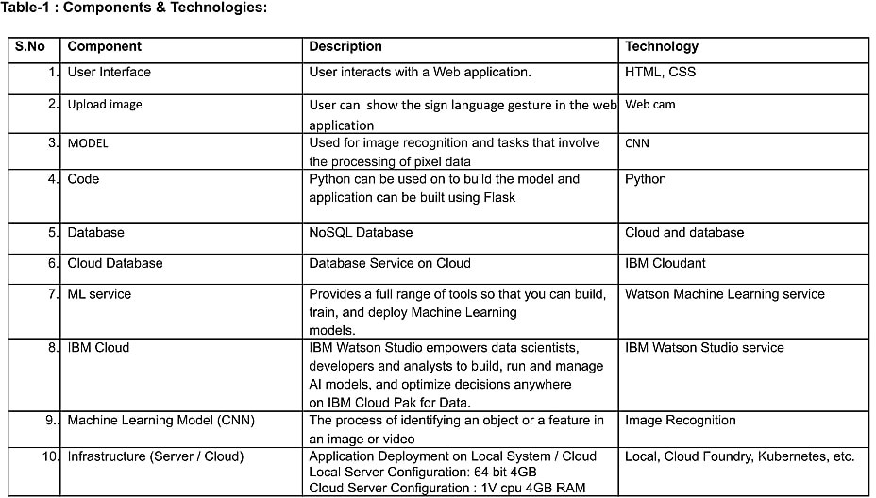

The components and technology table gives the detail explanation of the compponents and sources that is been used in the design.And it makes the way easier to understand about the componets with its deailed explaination that is been given in the table.Each and every component has its own application and it uses separate technology.The components that is been used in this design are as follows,

➤ User interface

➤ Upload image

➤ Model

➤ Code

➤ Databases

➤ Cloud database

➤ ML service

➤ IBM cloud

➤ Machine learning model(CNN)

➤ Infrastructure(Server/Cloud)

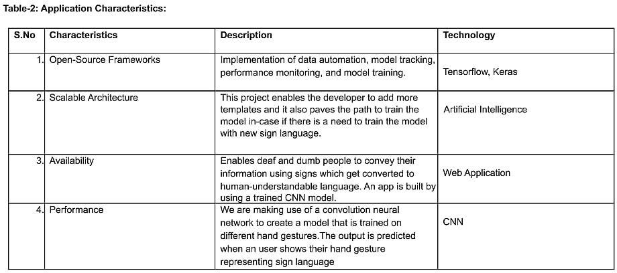

In order to design a system,it is important to examine the characteristics of the design.Whenever a design is been made it should compose of the following charactristics.

* Open-source framework
* Scalable architecture
* Availability
* Performance

# User Stories

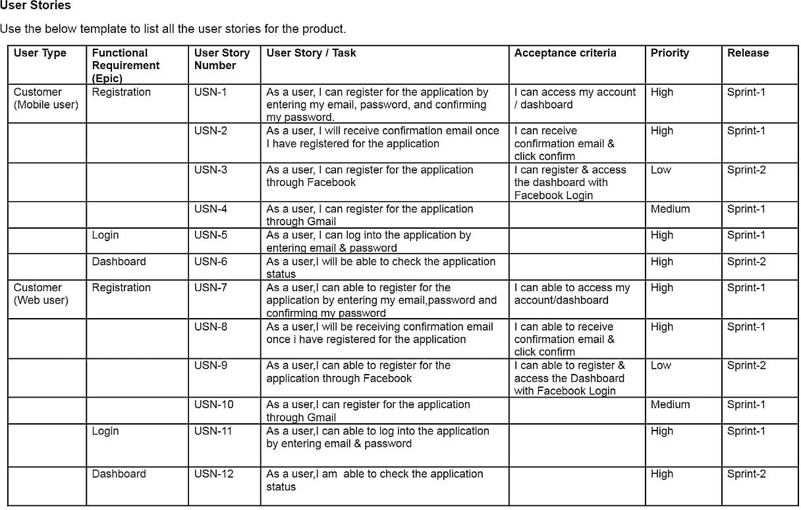

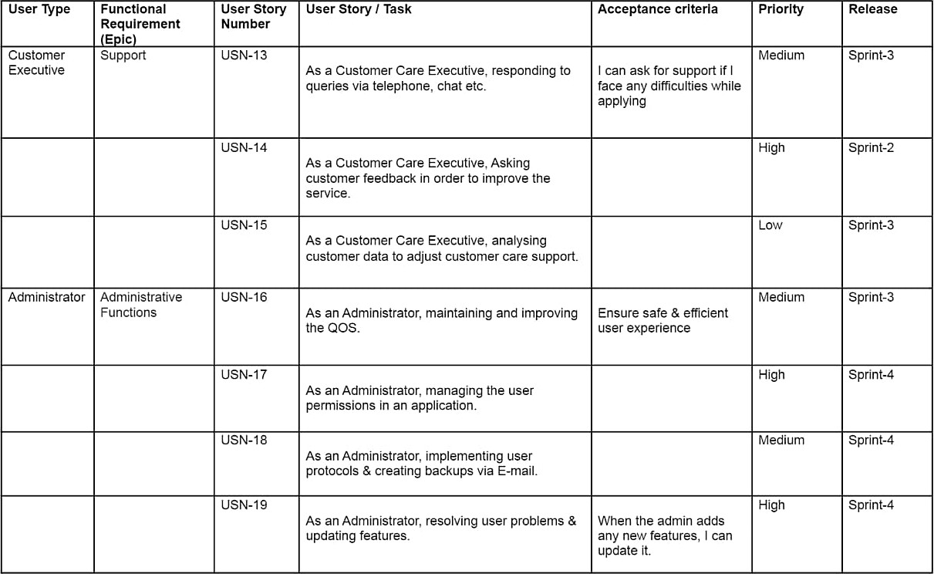

A user story is an informal, general explanation of a design feature written from the

perspective of the end user. Its purpose is to articulate how a design will provide value to the end user.A key component of agile software development is putting people ﬁrst, and a user story puts end users at the center of the conversation. These stories use non-technical language to provide context for the development team and their efforts. After reading a user story, the team knows why they are building, what they're building, and what value it creates. User stories are one of the core components of an agile

program. They help to provide a user-focused framework for daily work — which drives collaboration, creativity, and a better design overall.

# PROJECT PLANNING & SCHEDULING

Planning and scheduling are distinct but inseparable aspects of managing the successful project. The process of planning primarily deals with selecting the appropriate policies and procedures in order to achieve the objectives of the project. Scheduling converts the project action plans for scope, time cost and quality into an operating timetable.

# Sprint Planning & Estimation

Sprint planning & Estimation is the process for estimating the effort required to complete a prioritized task in the product backlog. This effort is usually measured with respect to the time it will take to complete that task, which, in turn, leads to accurate sprint planning.It is essential for,

Making teams accountable for deliverables

* + - Inducing discipline across the team members
    - Predicting the approximate time it will take to ﬁnish the project
    - Enabling better sprint management
    - Improving team productivity

# Sprint Delivery Schedule

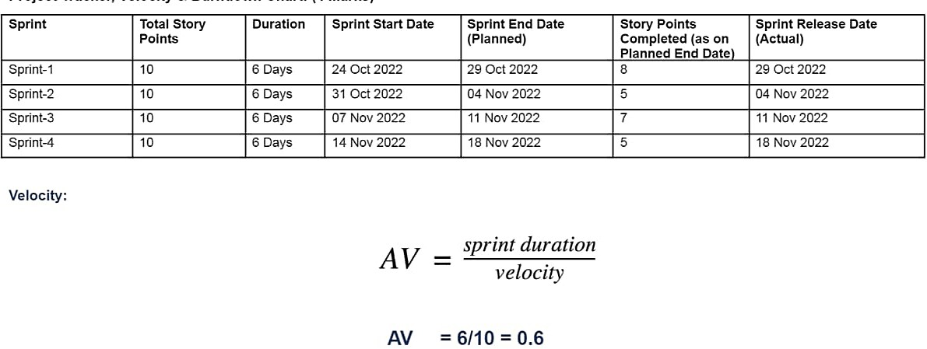

Since sprints take place over a ﬁxed period of time, it’s critical to avoid wasting time [during planning and development](https://www.plutora.com/solutions/use-cases/scaled-agile-framework-safe). And this is precisely where sprint scheduling enters the equation. Ideally, we create a sprint schedule early on in the development

process—before we get into the planning stage.Sprint schedules should be highly ﬂuid in the beginning. The sprint schedule includes,

* + - Start and end dates
    - Sprint goals
    - Stories
    - Story description

# Reports from JIRA ROADMAP

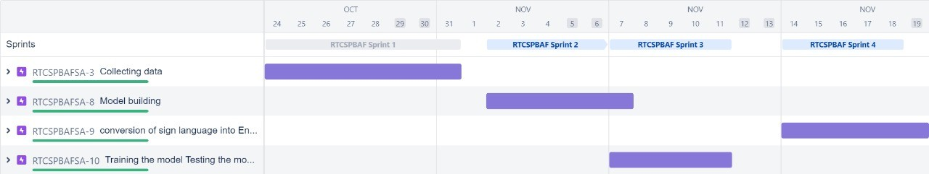

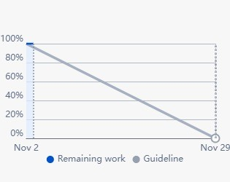**Sprint-1**

# Sprint-2

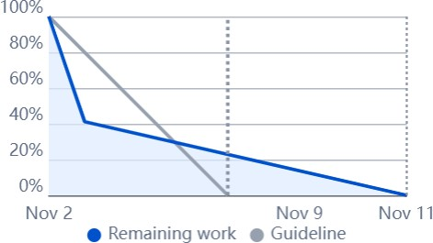

**Sprint-3**

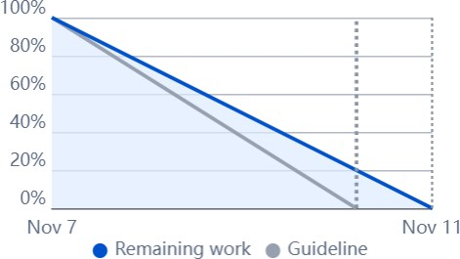

# Sprint-4

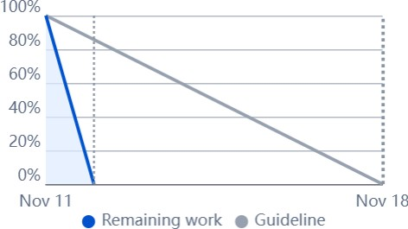

This are the ﬁnal reports that is been generated from the jira software.Initially with the help of the jira software we have made a plan for the sprint delivery.By using it so we are getting the four phase sprint report with roadmap.By using this we can assign and complete the work in the desired period.Tis will help to complete the work in time.

# CODING & SOLUTIONING

In order to design website that coverts sign language into English alphabets we need to develop the website.For developing the website,primarly we need a platform that is uesful for developing the code.Coding is nothing that which are the applications

developed by the developers in a certain computer language.Here we are using Python language for developing the website.

# Feature 1

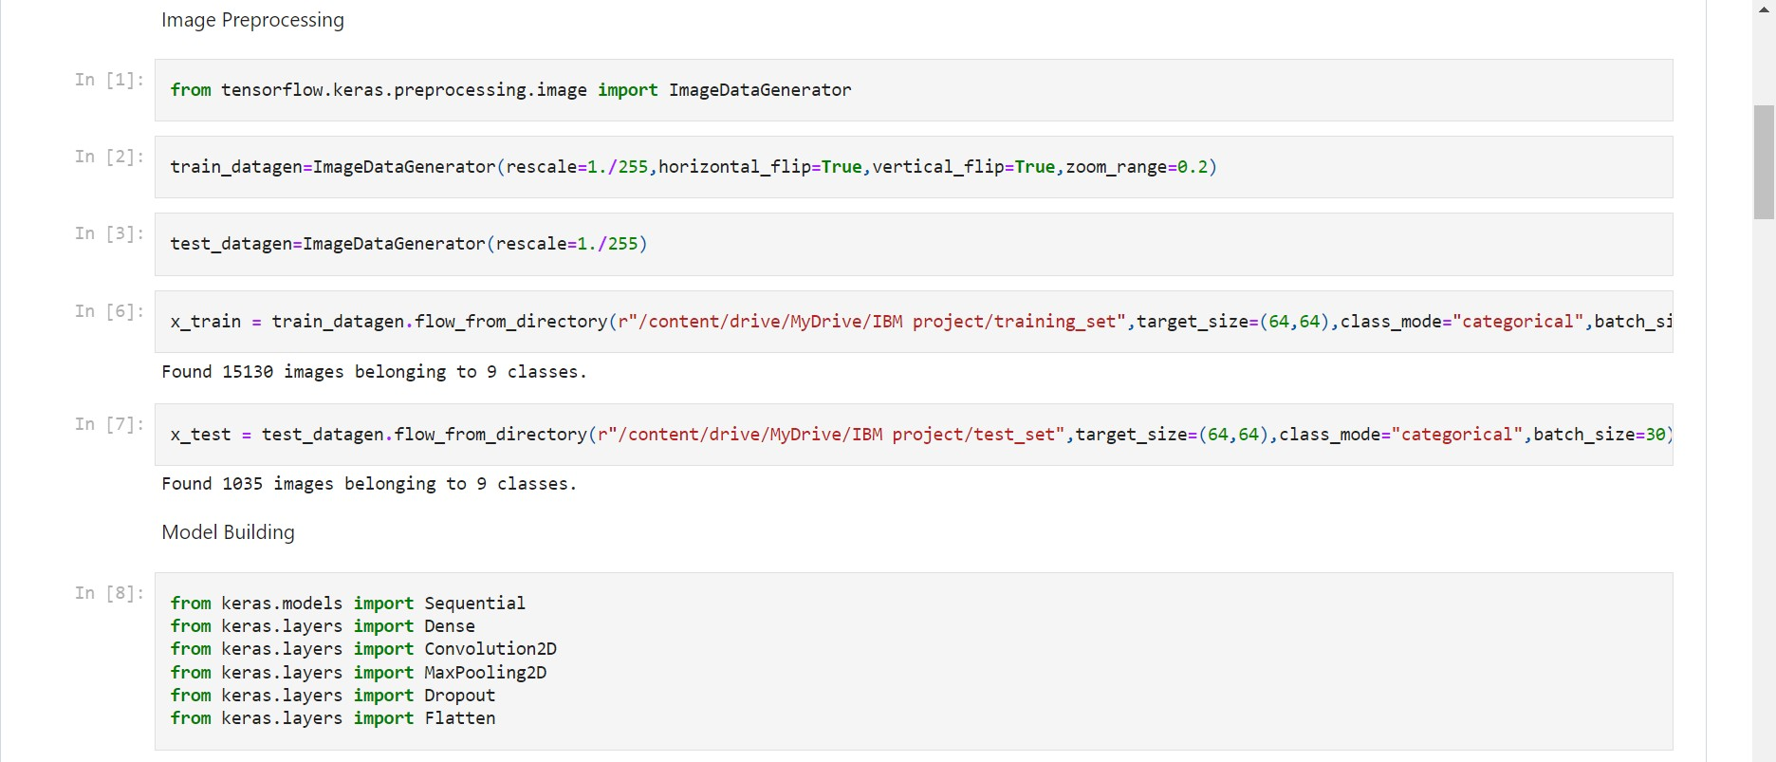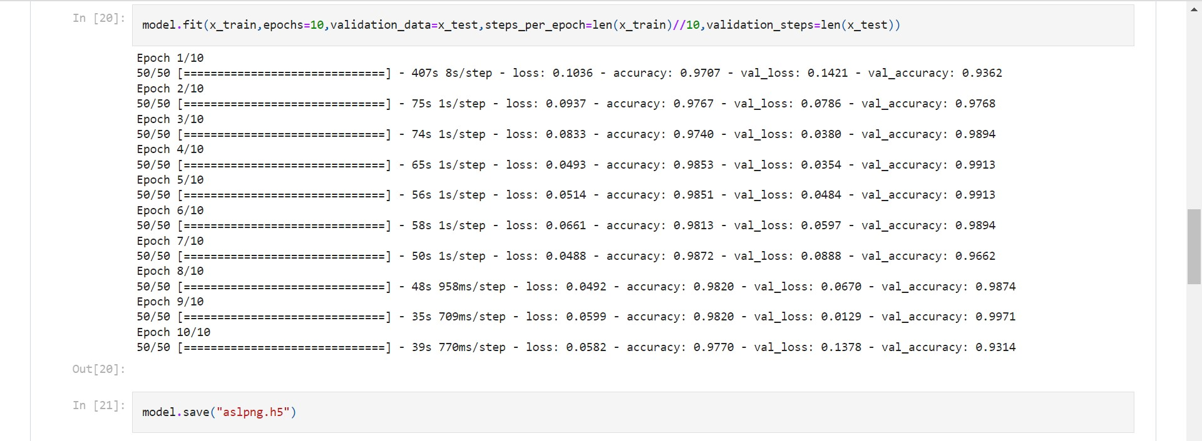

* 1. **Feature 2**

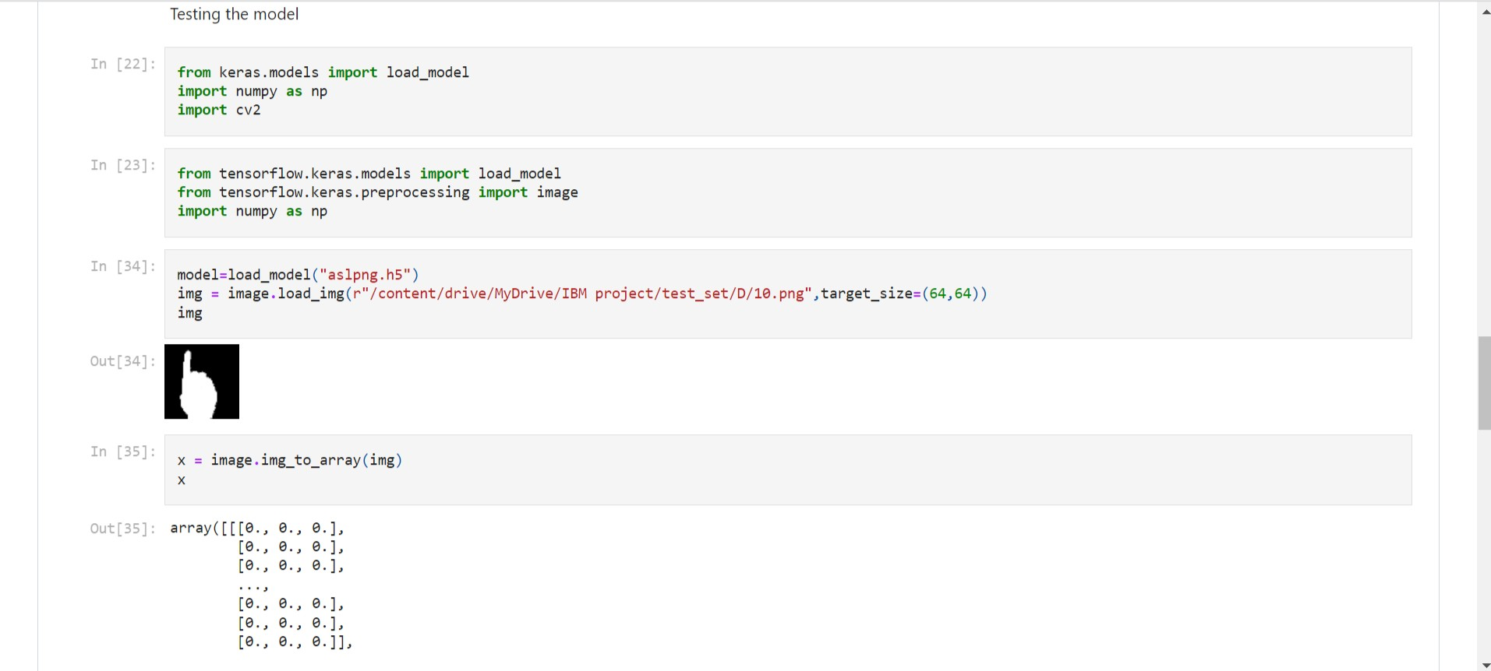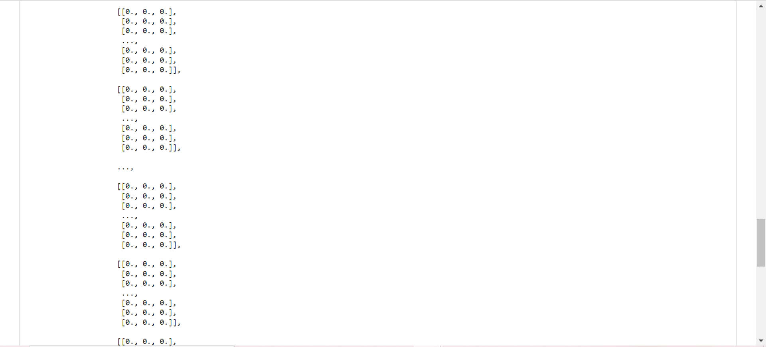

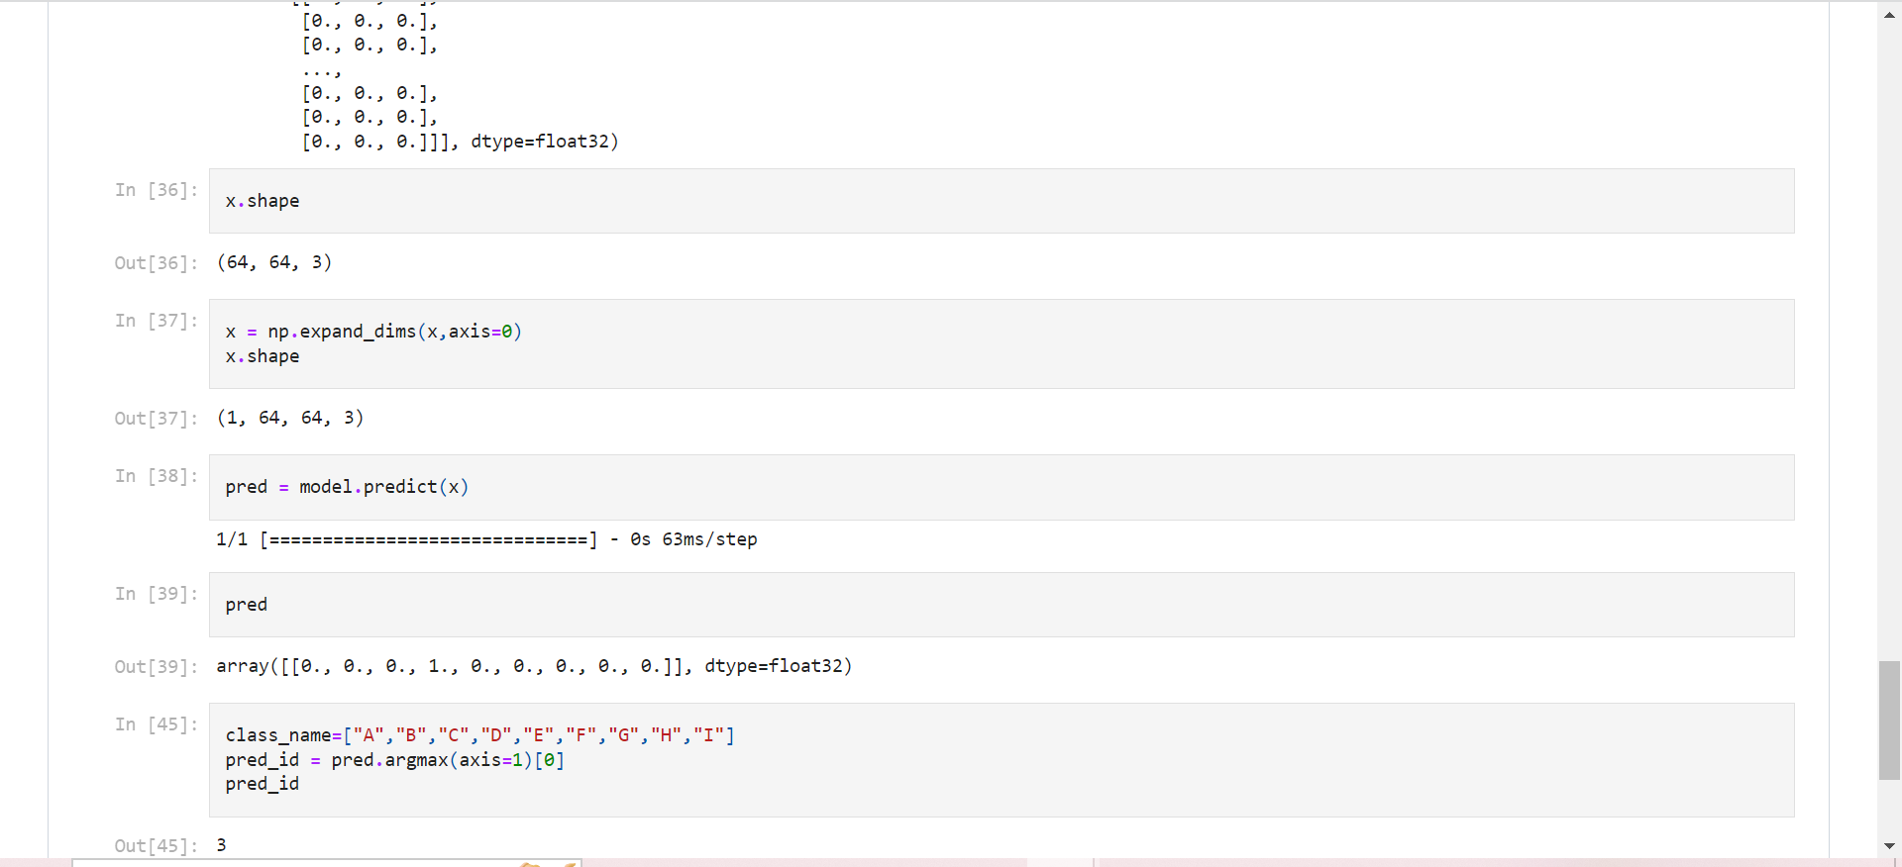

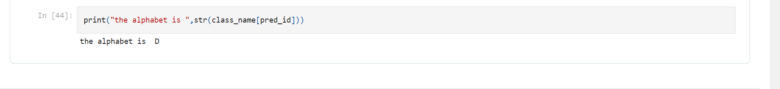

# 8.TESTING

After designing the website we need to test it whether it working ﬁnely.And it is mandatory to create a test report based on the testing.A test report is an organized summary of testing objectives, activities, and results.Test Report is a document which contains a summary of all test activities and ﬁnal test results of a design. Test report is an assessment of how well the Testing is performed. Based on the test report, we can better understand the designs quality and its performance.

# Test cases

A test case is nothing but a series of step executed on a design, using a predeﬁned set of input data, expected to produce a pre-deﬁned set of outputs, in a given environment.

It describes “how” to implement those test cases. Test case speciﬁcations are useful as it enlists the speciﬁcation details of the design.the following are the some of the speciﬁcations of test cases,

* + - Test case ID and objective with pre-requisite
    - Input data
    - Expected result
    - Actual result
    - Final result

# User Acceptance Testing

User acceptance testing (UAT), also called application testing or end-user testing, is a phase of software development in which the software is tested in the real world by its intended audience. UAT is often the last phase of the software designing process and is erformed before the tested software is released to its intended market

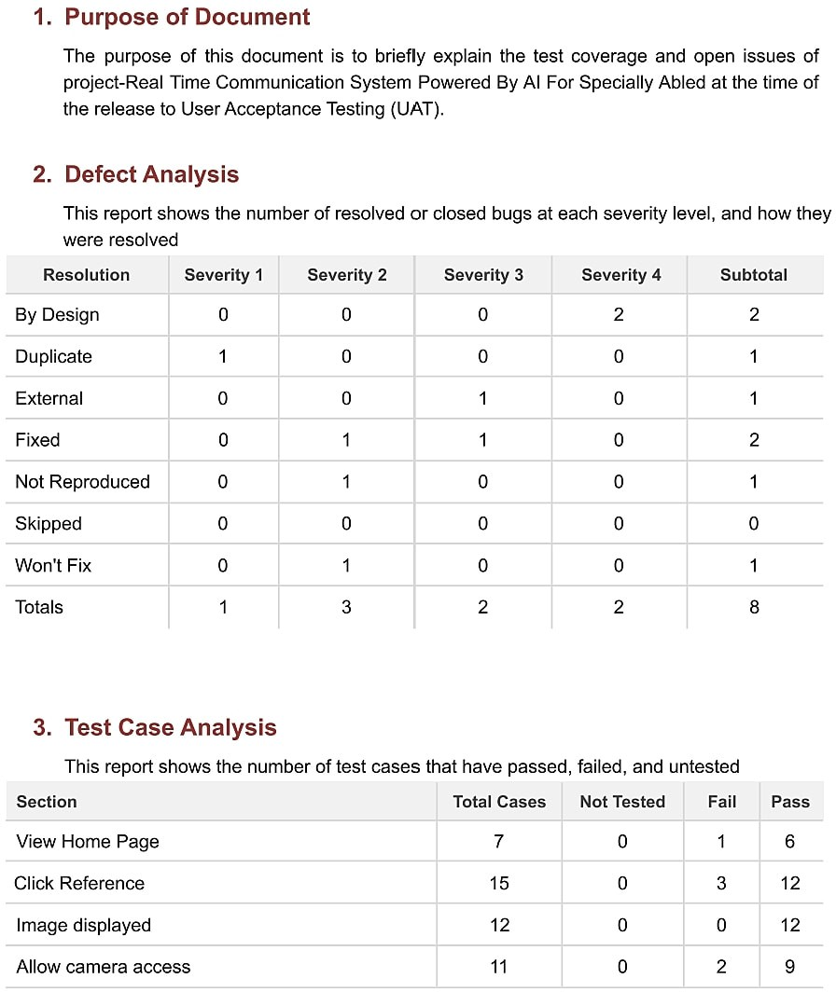

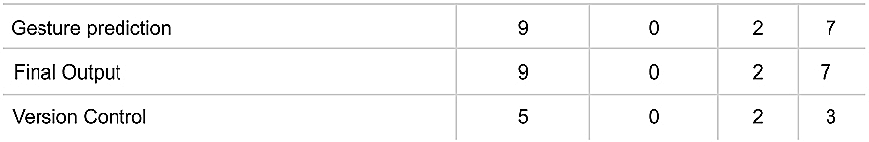

# RESULT

Finally we got the output for the desired input.our ultimate aim is to covert sign language into English alphanets.We have created the user interface for impleting it so.Thus the website was created successfully.As a result both the deaf and dump along with normal people can able to understand the desired language that is required for

them.

# Performance metrics

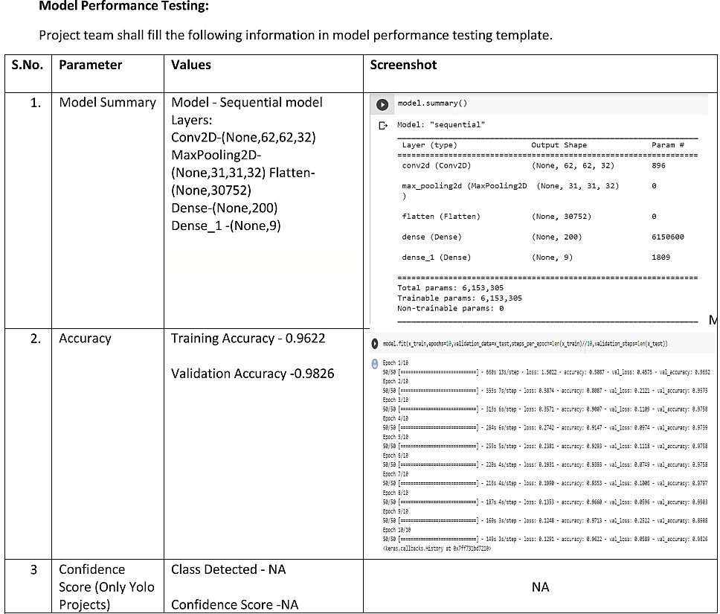

The proposed procedure was implemented and tested with set of images. The set of 15750 images of Alphabets from “A” to “I” are used for training database and a set of 2250 images of Alphabets from “A” to “I” are used for testing database. Once the

gesture is recognise the equivalent Alphabet is shown on the screen.

Some sample images of the output are provided below:

# ADVANTAGES & DISADVANTAGES

**Advantages:**

1. It is possible to create a mobile application to bridge the communication gap between deaf and dumb persons and the general public.
2. As different sign language standards exist, their dataset can be added, and the user can choose which sign language to read.

# Disadvantages:

1. The current model only works from alphabets A to I.
2. In absence of gesture recognition, alphabets from J cannot be identiﬁed as they require some kind of gesture input from the user.
3. As the quantity/quality of images in the dataset is low, the accuracy is not great, but that can easily be improved by change in dataset.

# CONCLUSION

Sign language is a useful tool for facilitating communication between deaf and hearing people. Because it allows for two-way communication, the system aims to bridge the communication gap between deaf people and the rest of society.

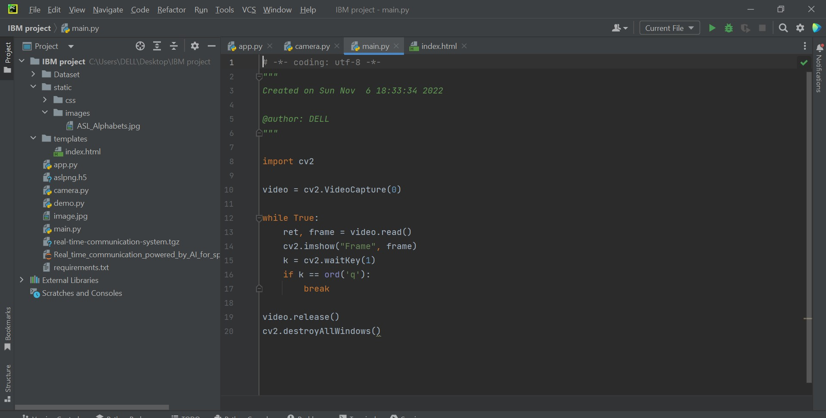The proposed methodology translates language into English alphabets that are understandable to humans. This system sends hand gestures to the model, who

recognises them and displays the equivalent Alphabet on the screen. Deaf-mute people can use their hands to perform sign language, which will then be converted into alphabets, thanks to this project.

# FUTURE SCOPE

Having a technology that can translate hand sign language to its corresponding alphabet is a game changer in the ﬁeld of communication and AI for the specially abled people such as deaf and dumb. With introduction of gesture recognition, the web app can easily be expanded to recognize letters beyond 'I', digits and other symbols plus

gesture recognition can also allow controlling of software/hardware interfaces.

We can develop a model for ISL word and sentence level recognition. This will require a system that can detect changes with respect to the temporal space. We can also

develop a complete product that will help the speech and hearing impaired people, and thereby reduce the communication gap.

# APPENDIX

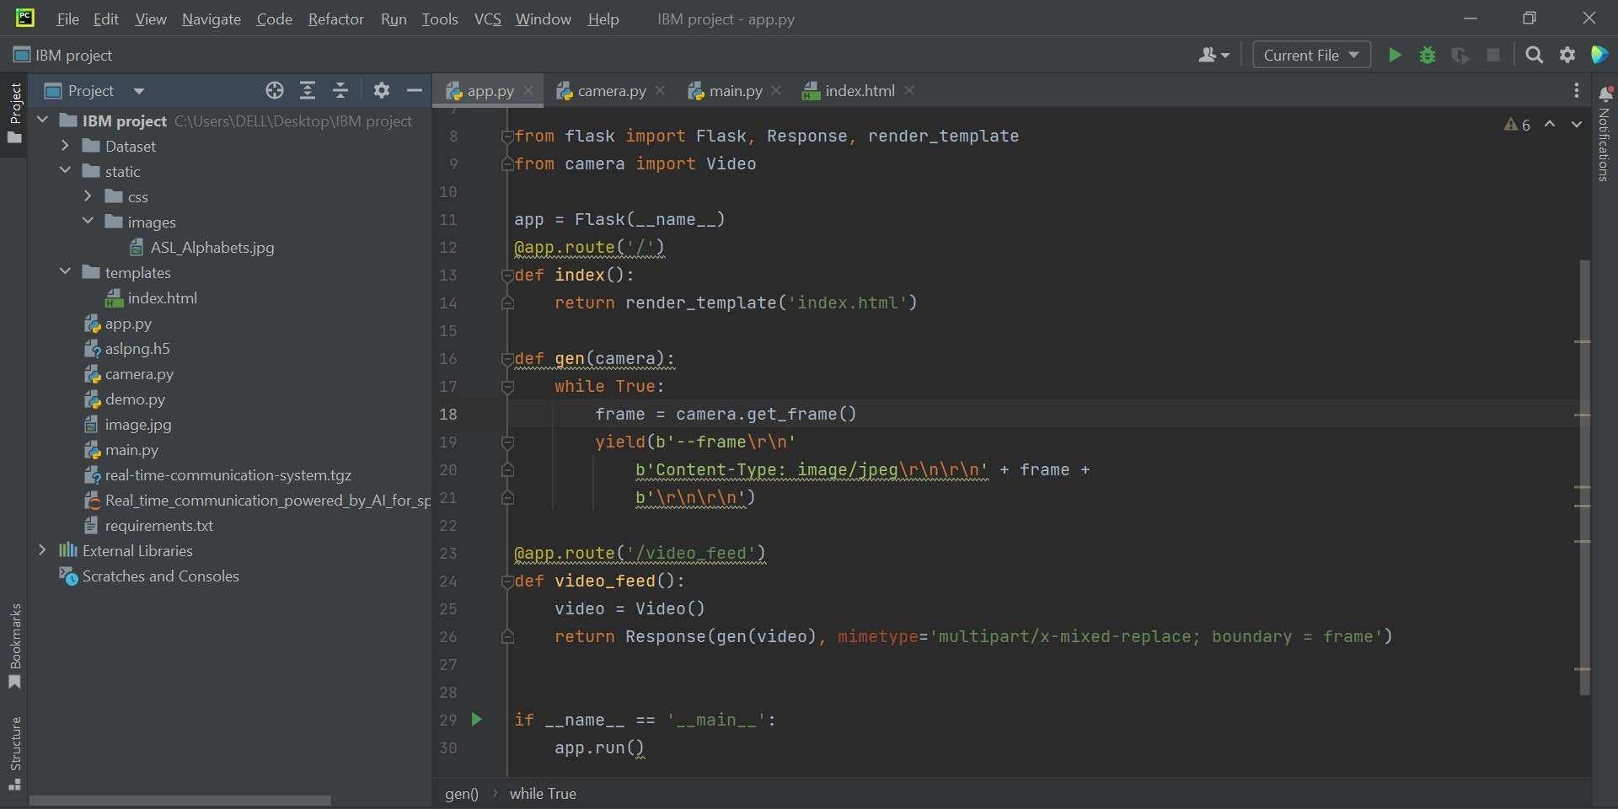Source Code for Model Training and Saving:

